Figure 1: Langflow Workflow of AI Interview Trainer Agent
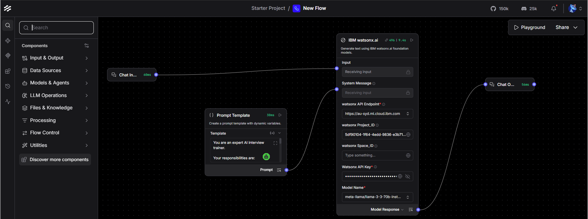
Figure 2: IBM watsonx.ai Resource Usage Dashboard
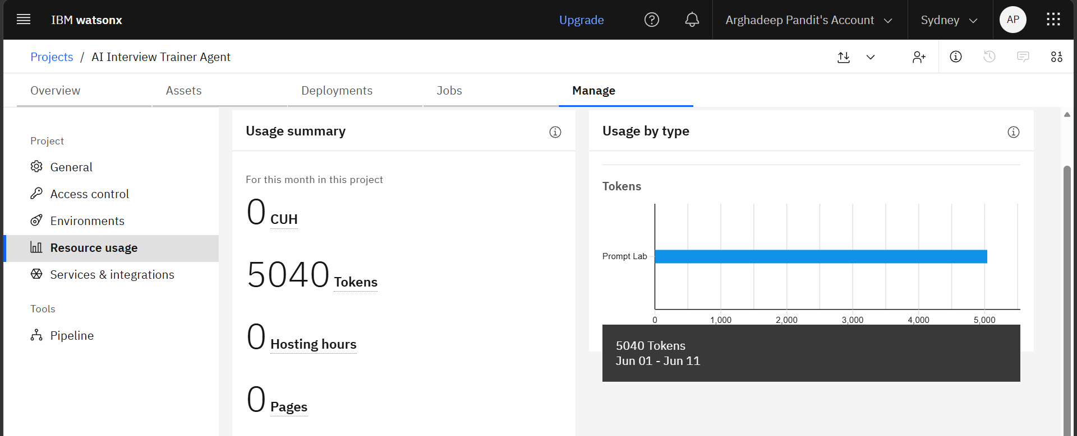
Figure 3: Campus Placement Mock Interview Generation
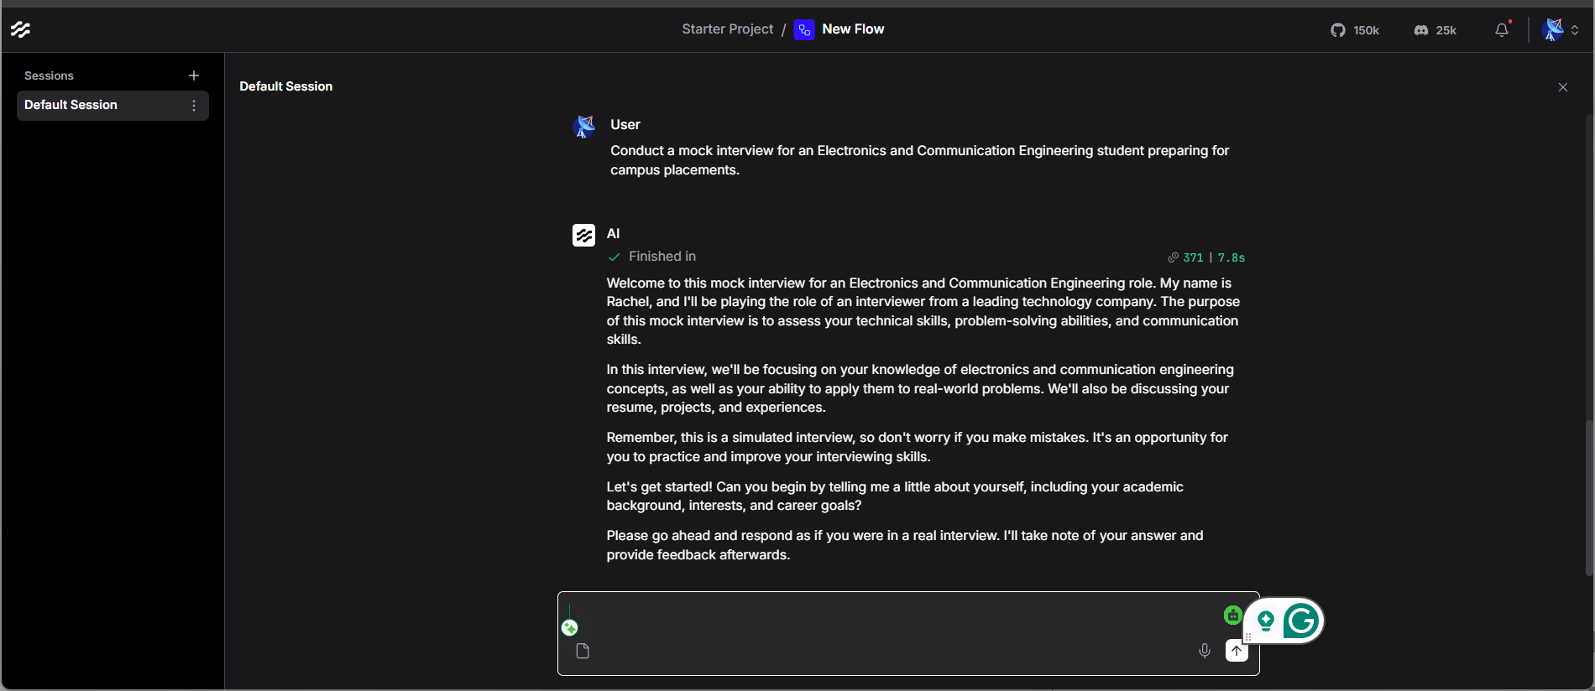

Figure 4: Technical Interview Question Generation
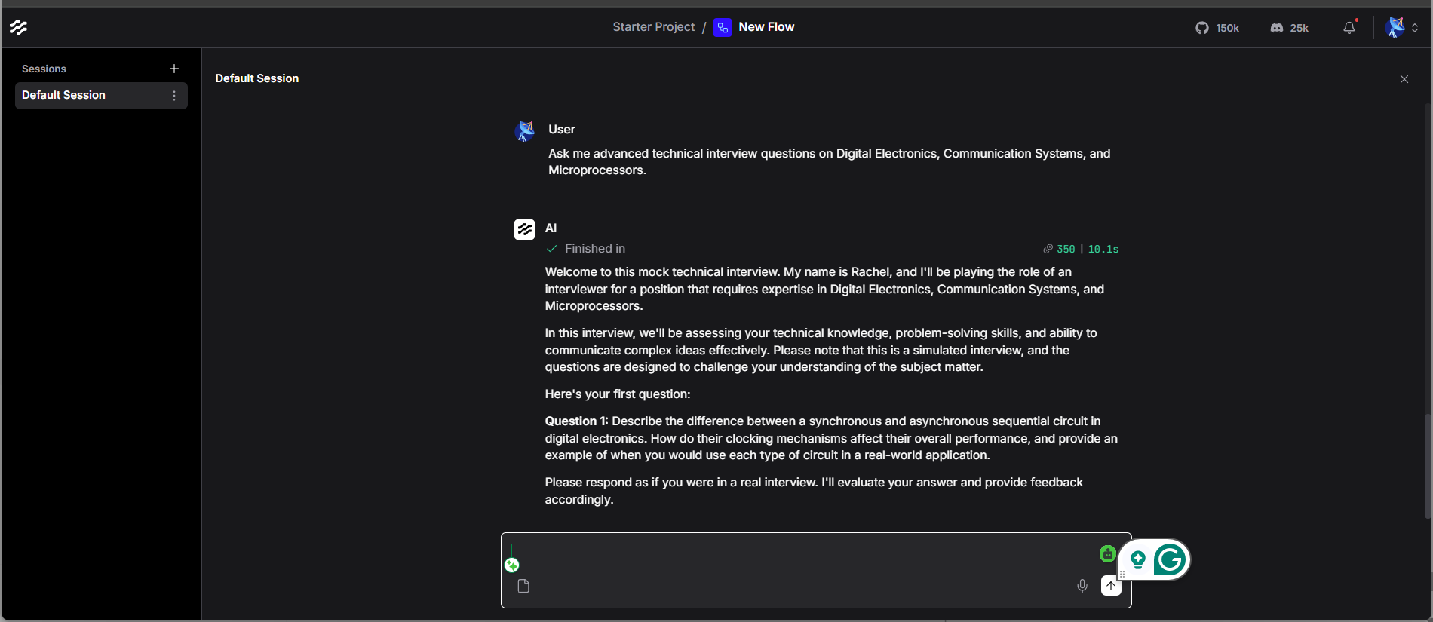
Figure 5: Answer Evaluation and Scoring Module
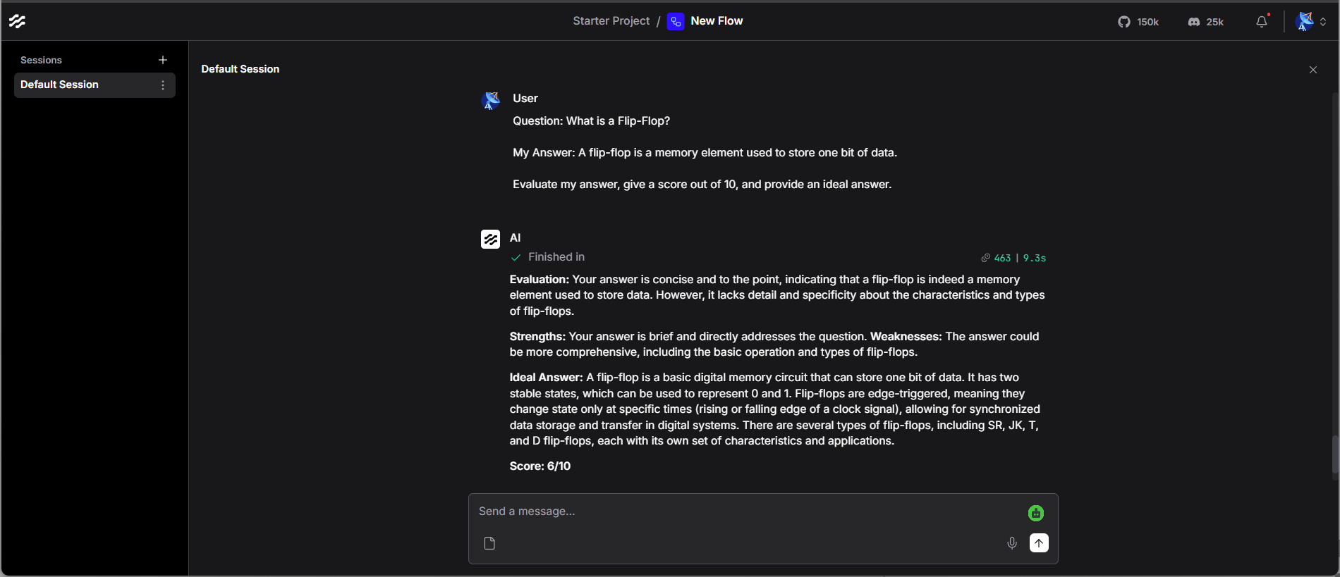

Figure 6: Personalized Feedback and Improvement Suggestions
